**FUNCTIONAL AND TECHNICAL COMBINED DOCUMENTATION**

**Page (62): Add Fixed Income (Front End Url:** http://localhost:8100/page62/Page62)

**Functional Picture:**

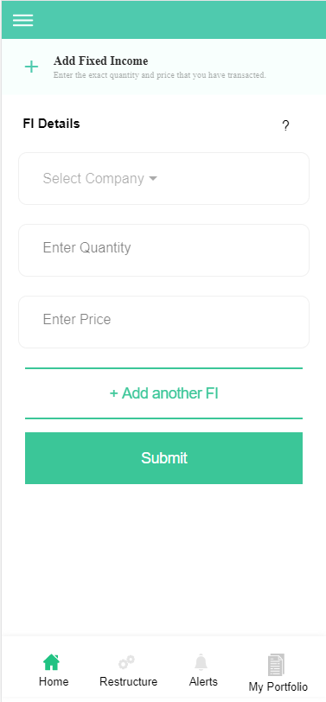

**In this Page, the user can enter the exact quantity, price and name of the fixed income securities that He/She has transacted by pressing the submit button. They can even add the fixed income securities that are recommended by the EasyVest Team in their portfolio by Pressing “+Add another FI” button.**

**Technical Explanation (Front End and Back End):**

**In Page62.tsx, we are calling following 1 API:**

1. TradeRegisterAPIFI: see backend python file. In this we are doing GET, PUT and POST requests.

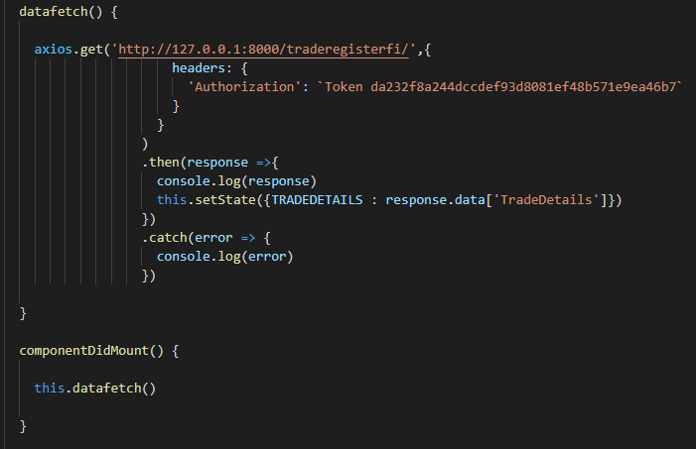

**As you can see, we are calling the** TradeRegisterAPIFI

**using this url:** [**http://127.0.0.1:8000/traderegisterfi/**](http://127.0.0.1:8000/traderegisterfi/)**. In this we are taking the Fixed Income data to populate it into the Dropdown if at all that user already have some existing Fixed Income Securities. Kindly see the given below backend Code for this GET request.**

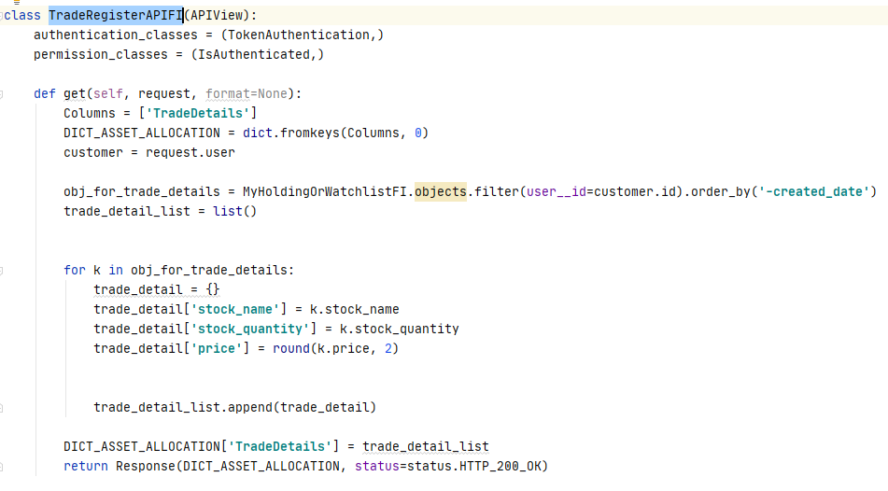

**The Above API is taking the data from the Fixed Income Database throwing the data on the front end through Response.**

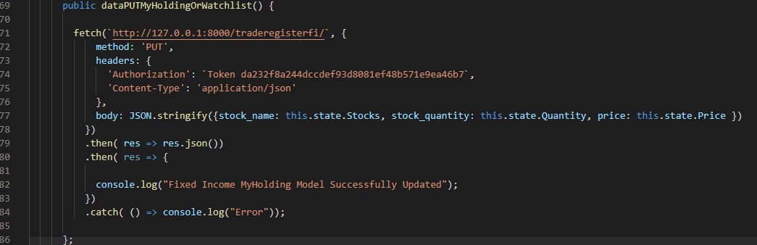

**As you can see, we are calling the** TradeRegisterAPIFI

**using this url:** [**http://127.0.0.1:8000/traderegisterfi/**](http://127.0.0.1:8000/traderegisterfi/)**. In this we are updating the Fixed Income Database while the user is updating his/her transaction price. We are calling this function by pressing “Submit” Button. Kindly see the given below backend Code for this PUT request.**

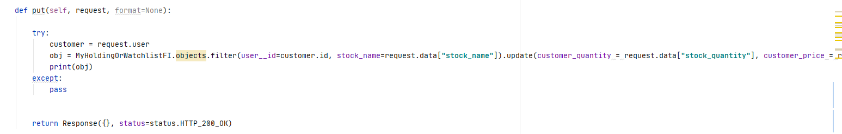

**Here we are updating the one of the FixedIncome database i.e. MyHoldingOrWatchlistFI model database. Please see this model database in models.py.**

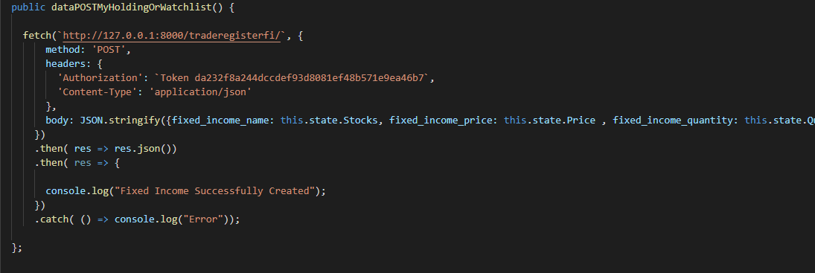

**As you can see, we are calling the** TradeRegisterAPIFI

**using this url:** [**http://127.0.0.1:8000/traderegisterfi/**](http://127.0.0.1:8000/traderegisterfi/)**. In this we are adding the new fixed Income security into the FixedIncomeHolding Database. We are doing this function by pressing ”+Add Fixed Income” . Kindly see the given below backend Code for this POST request.**

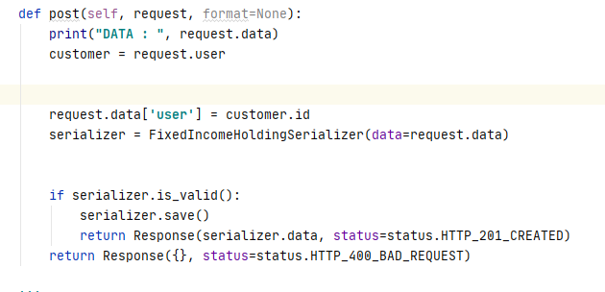

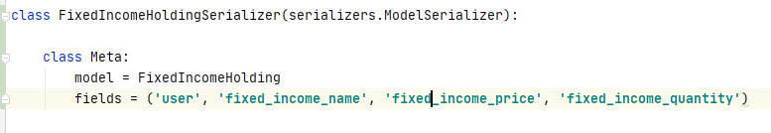

**Here we are adding new Fixed Income security using POST request into the FixedIncomeHolding using FixedIncomeHoldingSerializer.**

**DONE!!!**